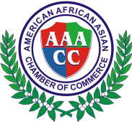
American African Asian Chamber of Commerce
40 Wall St.28st FL.New York,NY 10005 U.S.A
Tel:917-903-2228 917-780-5425
Email:aaacc168168@gmail.com
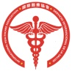 International Healthcare Association
尖端生物科学医疗团队成员介绍
Introducing the cutting-edge
scientific medical engineering team
目的：推广我们团队的主要产品–-Wu Ji Tong(经络通)，Prostaid(前列沛)和ShapeTea(纤体茶)。该团队正在完成研究并将开发和生产皮肤细胞外用产品，和抑制、阻止异细胞的转移和再转移、促进细胞正常生长的外用产品。
Purpose: Promote our team’s major products- Wujitong, Prostaid, and Shape Tea. The team is now in the process of finishing research and will develop and manufacture dermacell topical products;and productsinhibiting and stopping metastasis and remetastasisof variant cells, promoting cells normal growth
团队的负责人：梁迈克 爵士
Team Leader: Sir.Michael Leung
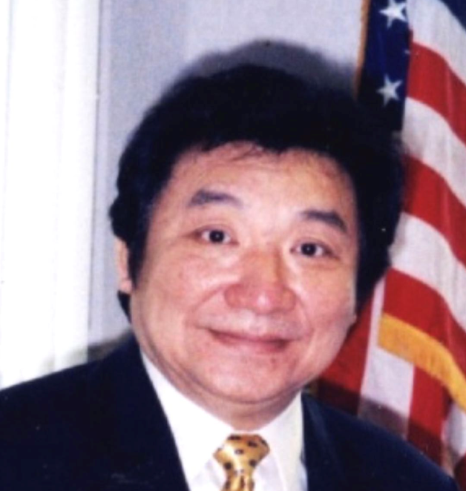
Chairman Sir. Michael Leung
一、生物研发团队
Industrial Development Committee
1、张瑞克博士（Dr. Ric Zhang）
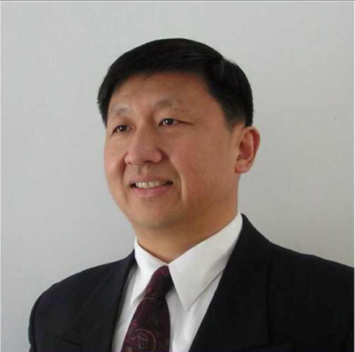
拥有多项成就的高级研究员，他从事生物工程实验室研究和工业外用和口服产品开发研究30多年; 他熟悉各种植物成分、利用生物物理学方法开发出多种有效的功能性产品。
Senior Researcher with many achievements, Bio-Engineering lab-research and Industrial Topical and Oral Products developing research for more than 30 years;He isfamiliar with various botanical ingredientsand has manufactured many functional products by using bio-physics method.
2、Alexander G. Hammer：
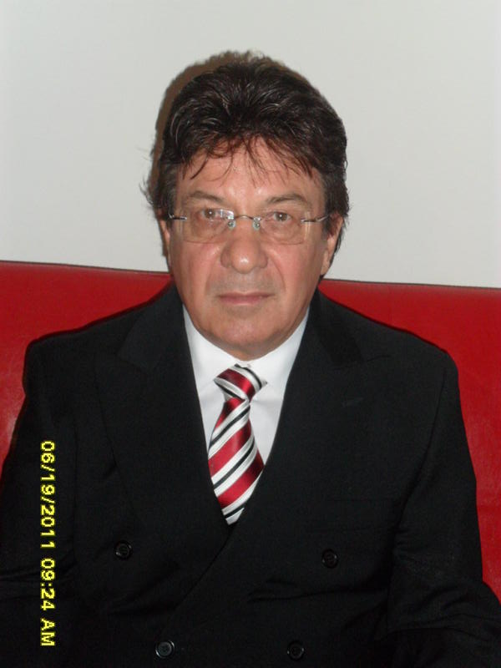
资深的工业产品开发及研究总监，拥有超过40年的丰硕成果。他丰富的工作经验，包括在雅诗兰黛和纽约Twin实验室的领导职位。另外他在德国，巴西和阿根廷有国际经验。在巴西，他的作品连续两次在“时尚杂志”上发布。他拥有两项美国创新化妆品产品专利。
Industrial Products Senior Developer and Research Director with abundant achievements for more than 40 years.His extensive work experience, includes leading positions with Estee Lauder and Twin Labs in New York. In addition he has international experience in Germany, Brazil and Argentina. In Brazil, his work was shown on Vogue's Magazine cover two consecutive times.
He is the holder of two Unites States patents for innovative cosmetic products.

3、 冯旭东(Dr. Xudong Feng)
冯旭东博士现在哈佛医学院从事脂肪代谢和糖尿病的研究，熟悉西药和中药的研究开发，在神经科学等领域都有独到的造诣。
Dr. Feng Xudong is currently engaged in research of fat metabolism and diabetes on Harvard Medical School. He is familiar with the research of western medicine and traditional Chinese medicine. He has accomplishments in many fields such as neuroscience.

4、辛显桐教授（Professor Xian Tong Xin）
哥伦比亚大学教授，专门从事皮肤干细胞研究，拥有目前重要的专利成果
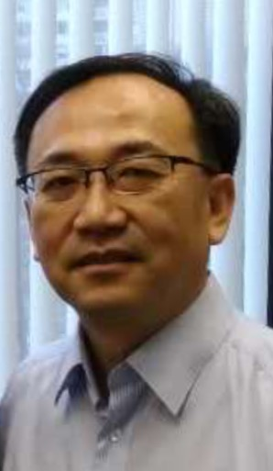
Columbia University Professorspecialized in derma stem-cell research with currentlyimportantpatterned achievements

5、强力教授(Professor Qiang, Li)
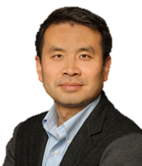
哥伦比亚大学教授，目前有许多研究和专利成国，特别是在脂质代谢方面的成就。
Columbia University Professor，with many currently research and patterned achievements, especially in lipids metabolis.
6、顾臻教授(Professor Gu, Zhen)
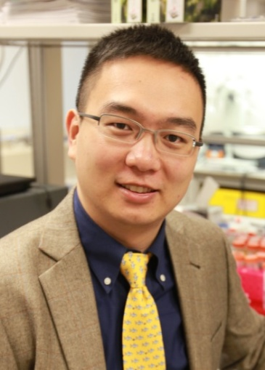
北卡罗莱纳大学教授，北卡罗来纳大学和北卡罗来纳州立大学联合实验室，目前有许多研究成果，特别是在活性药物成分递送系统方面。
University of North Carolina Professor, Joint lab of University of North Carolina and University of North Carolina State, with many currentlyresearch patterned achievements, especially in active pharmaceutical ingredients delivery system.

7、贺军（Jun He）
临床研究主管，从事临床研究与发展超过30年。
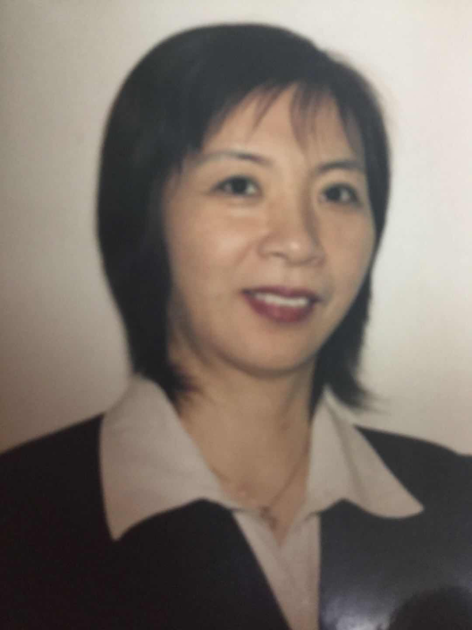
Clinical Research Coordinator, engaged in clinical research and developing for than 30 years.

管理团队
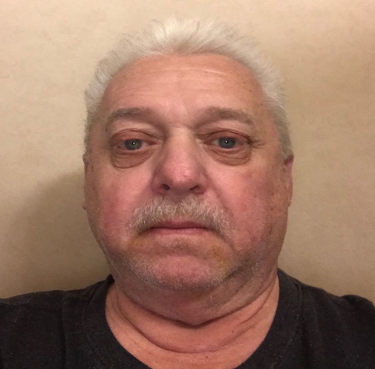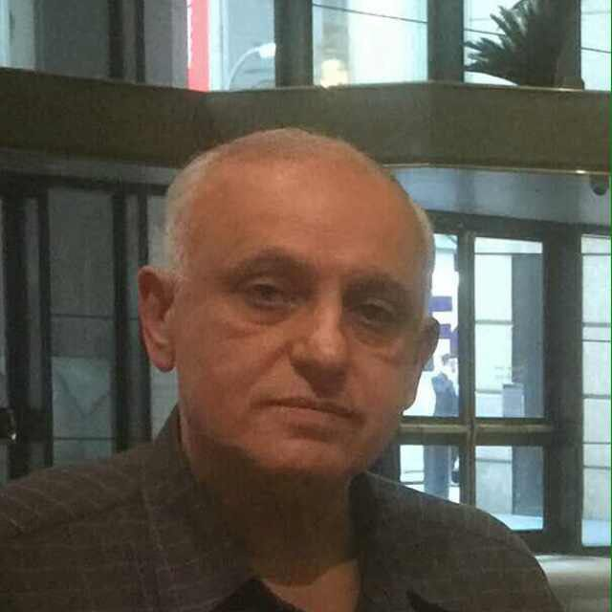
John De Prima Esmail Kashanian
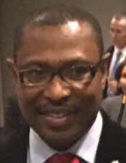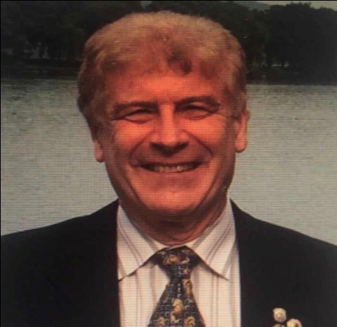
Ishmael Nii Dodoo Richard Lipetz
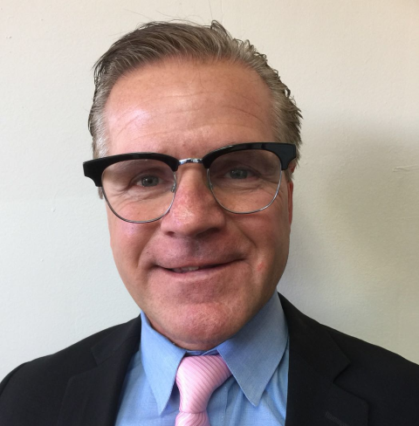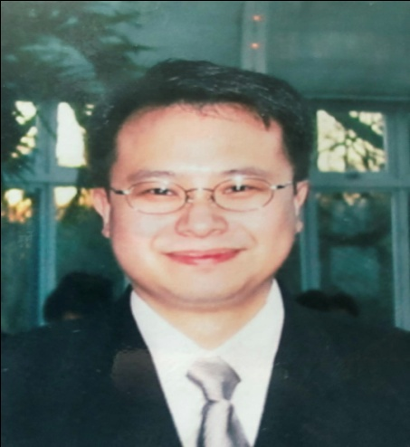
Keith Jacobsen Daniel Lam
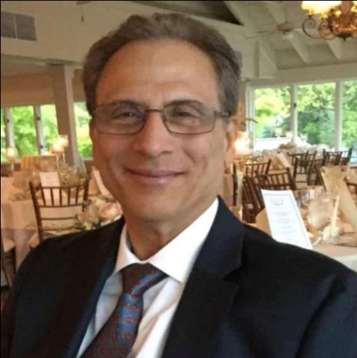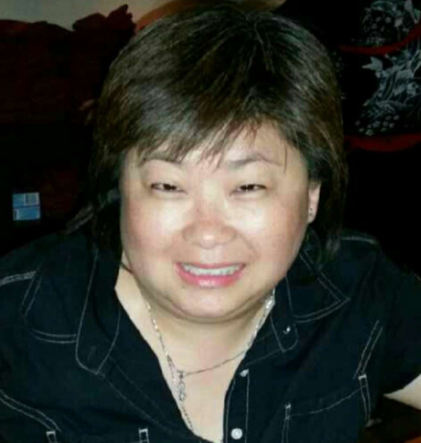
Thomas Kearon Elaine Wong
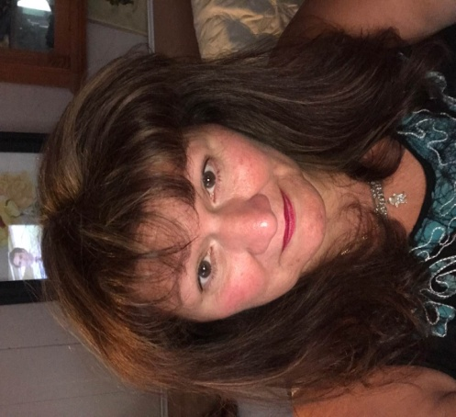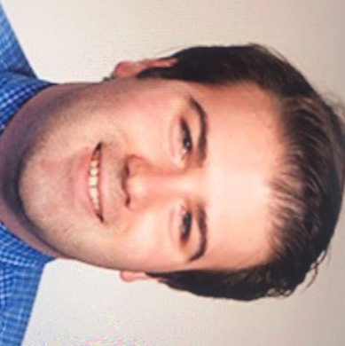
Doreen Varrichio Brett Lipetz
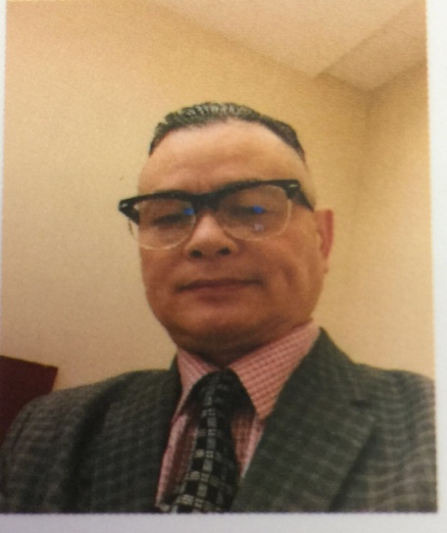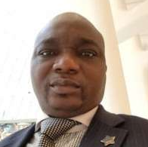
Jianshi Xu Kazeem F. Bello
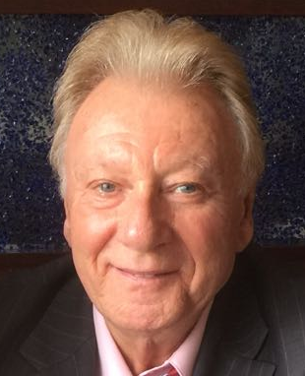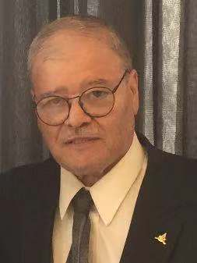
Robert Abraham Michael De Luca
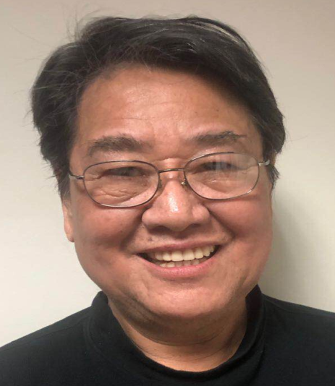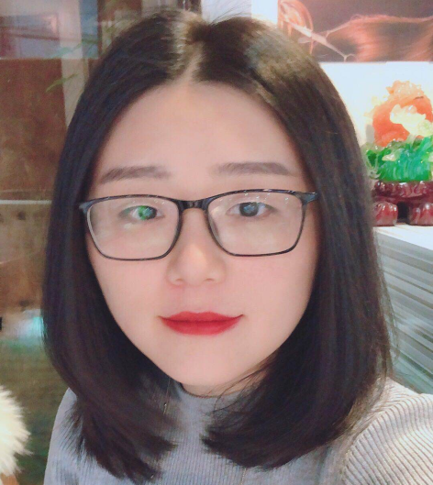
Ken Lee Yingke Yang
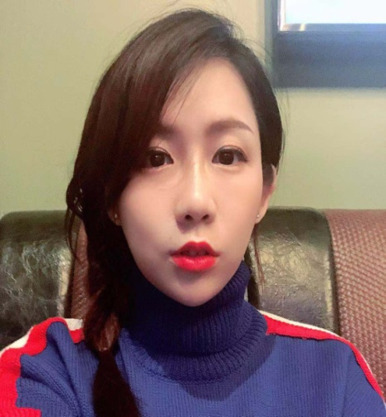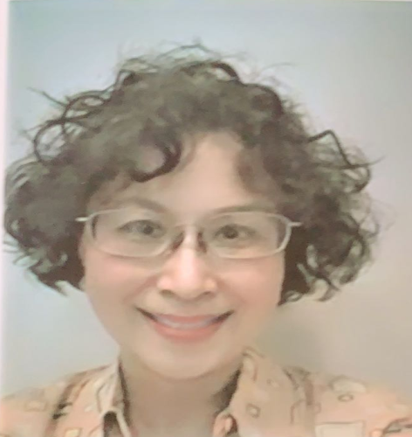
Yuan Zhang Emily S. Miller

